**Chapter 1: Lines and Shapes**

Geometry is the study of shapes and the space around us points, lines , rays and line segments and curves are the important elements of geometry.

|  |  |  |
| --- | --- | --- |
| **Point:** | A point is a dot (.) |  |
| **Ray:** | A ray start at a point and goes on forever in one direction. It has one end point. It does not have a definite length. |  |
| **Line:** | A line is straight and goes on forever in both direction. It has no end point. It does not have a definite length. |  |
| **Line segment:** | A line segment is a part of a line. It has two end points. It has definite length. |  |

|  |
| --- |
| **Flat Shapes:** Flat shapes are the shapes that can be traced on a sheet of paper. **e.g. Square, Rectangle, Triangle, Circle, Oval** |
| Flat shapes are also called 2-D shapes or 2- dimensional shapes. as they have only 2 dimensions - **length and breadth.** |

|  |  |
| --- | --- |
| **Square:** A square has 4 sides and 4 corners. All the sides of a square are equal. |  |
| **Rectangle:** A rectangle has 4 sides and 4 corners. Opposite side of a rectangle are equal. |  |
| **Triangle:** A triangle has 3 sides and 3 corners. |  |
| **Circle:** A circle is made up of points that are at same distance from the centre. |  |

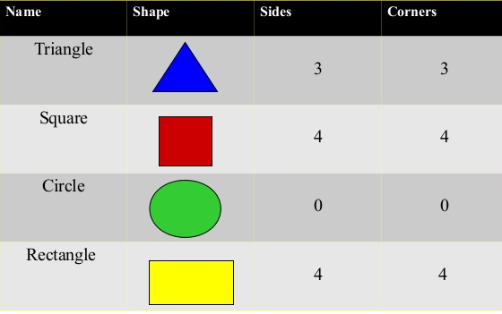

**Exercise**

|  |  |
| --- | --- |
| 1. | Draw the following: Point and Line |
| 2. | Answer the questions |
| a. | Give two examples of ray in real life: **sun rays and laser light.** |
| b. | How many points can be drawn in the line.: **Infinite number of points can be drawn on line.** |
| c. | Which of these has a length that can be measured- line, ray or line segment? **line segment.** |
| 3. | Draw line segment of given lengths  a. QR= 9cm b. ST=7cm c. JK= 7cm, d. DE=4cm |
| 4. | What are the properties of a circle? |
| Ans: | **A circle has no sides and no corners.** |
| 5. | How are a square and triangle different from each other? |
| Ans: | **In a square, all the 4 sides are equal. In a rectangle, opposites sides are equal.** |
| 6. | How many line segment can be drawn from one point? |
| Ans: | **Infinite number of line segments can be drawn from a point.** |
| 7. | How are these shapes are same? How are they different? |
| Ans: |  |
| 8 | Identify them |
| Ans: |  |
| 9. | Draw the following: a) Ray b) Line segment |
| 10. | How many points, rays, curves and line segments are there in the given figure |
| 11. | Draw circle using coin |
| 12. | What are the properties of a rectangle. |
| **Ans:** | **A rectangle has 4 sides and 4 corners. Opposites sides of a rectangle are equal.** |
| 13. | What is the same and different in these shapes? |
| **Ans:** |  |
| 14. | Measure the lengths of the line segments in the given shapes. |
| 15 | Measure the line segment OR and OS. Write your observations. |

**Chapter 2: 3-D Shapes**

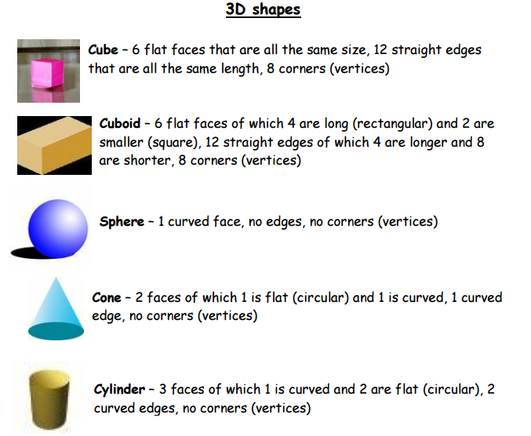

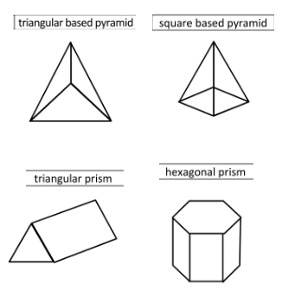

|  |  |  |  |  |
| --- | --- | --- | --- | --- |
|  | **Faces** | **Edges** | **Corners** |  |
| Cube | 6 | 12 | 8 | All squares flat faces can slide |
| Cuboid | 6 | 12 | 8 | Rectangular faces can have square faces  Can slide |
| Sphere | 1 | 0 | 0 | One curved face  Can roll |
| Cylinder | 3 | 2 | 0 | Two flat faces  One curved face  Can roll and slide |
| Cone | 2 | 1 | 1 | One curved face  One flat face  Can roll and slide |

**Exercise**

|  |  |
| --- | --- |
| 1. | Write the name of each 3D shape  A. dice: **cube** b. drum: **cylinder** c. Ice cream cone: **cone** |

**2. Match the following 3-D shapes with their properties**

|  |  |
| --- | --- |
| Cuboid | 3 faces |
| Cone | No edges, no corners |
| Cube | 1 curved face, 1 flat face |
| Cylinder | 12 edges, opposite faces equal |
| Sphere | 6 square faces |

|  |  |
| --- | --- |
| **3.** | **Fill in the blanks** |
| A | A cuboid has --------------------- faces and --------------------- corners. |
| B | A cylinder has ------------------ curves faces and ------------------- flat faces. |
| C | ------------------ has 1 curved surface. |
| 4. | Answer the following |
| a. | How is a cube different from a cuboid |
| **Ans:** | **A cube has 6 square faces. All faces are equal. A cuboid also has 6 faces but not all the faces are equal. A cuboid can have square faces.** |
| B | How is sphere is different from a cylinder. |
| Ans: | **Both have one curved face. Sphere can roll. Cylinder can roll and slide and have two flat faces.** |
| 5. | How are these shapes are same: cylinder, cone, sphere |
| **Ans:** | **All shapes have one curved face.** |
| 6. | Write the names of 2 objects that are looked like cuboids. |
| **Ans:** | **Book, bricks, box etc.** |
| 7. | Identify one 2-D shape that can be seen on the face of the given 3-D shape? |
| Ans: | Square, Rectangle, Triangle, Circle. |
| 8. | Find one shape that does not fit into the group. Give reasons. |
| Ans: | a. cube, cuboid, sphere: **Sphere. Sphere has curved face while cube and cuboid don't have curved face.** |
|  | b. Sphere, cylinder, prism: **Prism. Prism don't have curved face while sphere and cylinder have curved face.** |
|  | c. prism, pyramid, cylinder: **Cylinder**. **Cylinder don't have triangular face while prism and pyramid have triangular faces.** |
| 9. | How many faces do these shapes have |
| Ans: | **1) Cube: 6 faces 2) Cone: 2 faces**  **3) cylinder: 3 faces 4) Cuboid: 6 faces** |
| 10 | **Fill in the blanks** |
| A | A cube has -----------------edges, ------------------- corners and ---------------------- faces. |
| B | A cone has -----------------edges, ------------------- corners and ---------------------- faces. |
| C | A cylinder has -----------------edges, ------------------- corners and ---------------------- faces. |
| D | A sphere has -----------------edges, ------------------- corners and ---------------------- faces. |
| 11. | What is one common property between these shapes |
| **A** | **Cube and Cuboid: 6 faces** |
| **B** | **Cone, Cylinder: 1 curved face** |
| **C** | **Cylinder, Sphere: 1 curved face** |
| **D** | **Cube, Prism: Square faces** |
| **E** | **Cone, Sphere: 1 curved face** |
| **12.** | Name 2 shapes that have the following |
| **A** | **One curved face: sphere, cone** |
| **B** | **No corners: sphere, circle** |
| **C** | **6 flat faces: cube, cuboid** |

**Chapter 5: Time on a clock**

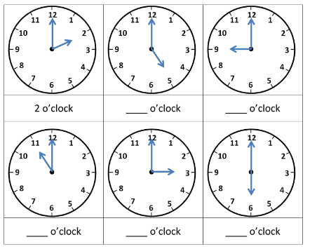

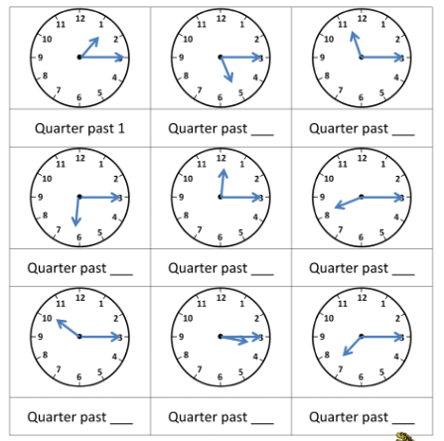

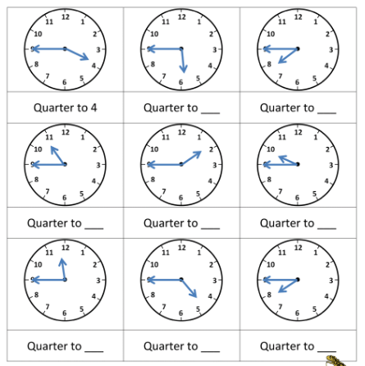

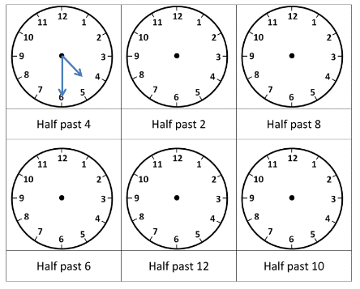

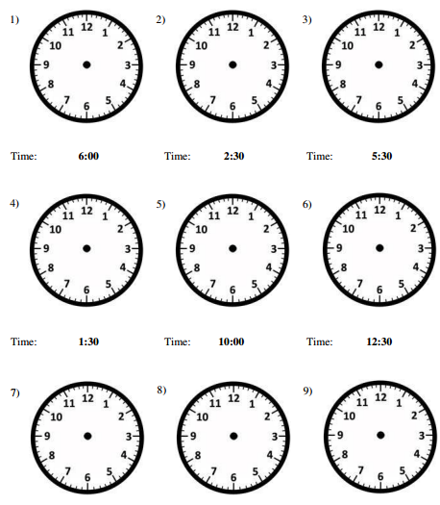

1. Draw clocks to show the given time.

|  |  |  |  |
| --- | --- | --- | --- |
| 8:05 | 20 minutes past 12 | 11:03 | 7:47 |
| quarter to 4 | half past 5 | quarter past 6 | quarter 7 |

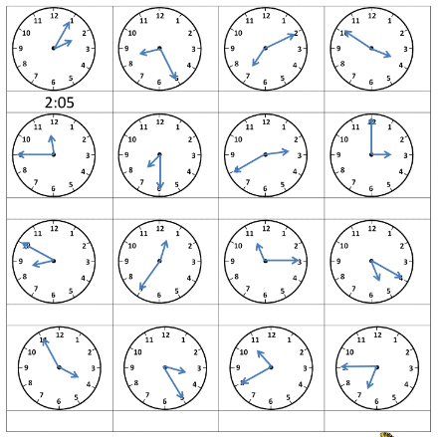

|  |  |  |  |
| --- | --- | --- | --- |
| 4:03 | 3:19 | 9:22 | 10:31 |
| 12:30 | 4:34 | 6:40 | 7:50 |

**Write the time in the 24-Hour format**

|  |  |
| --- | --- |
| 1. | 9:56 AM: |
| 2. | 5:10 PM: |
| 3. | 7:05 AM: |
| 4. | 12:15 AM: |

**Complete the table**

|  |  |  |  |
| --- | --- | --- | --- |
| Activity | Time | Time in 12-hour format | Time in 24-hour format |
| Come back from office | 6 o' clock in the evening |  |  |
| Get dressed for office | 7:30 in the morning |  |  |
| Play with children | 6:30 in the evening |  |  |
| Have dinner | 8:30 in the evening |  |  |
| Wake up | 7:00 in the evening |  |  |
| Have breakfast | 8:30 in the morning |  |  |

**Arrange the given activities in the order in which they take place in timeline.**

**How will you write 3 hours before 12:03PM in the 24-hour format?**

**Draw clock faces and show the following time**

|  |  |  |  |
| --- | --- | --- | --- |
| 5:15 | 7:35 | 9:55 | 13:25 |
| 5 minutes past 2 | 10 minutes to 6 | 5 minutes past 11 | 25 minutes to 10 |

**Draw clock faces and show the following time**

|  |  |  |  |
| --- | --- | --- | --- |
| 2:46 | 8:12 | 9:27 | 1:43 |
| 3 minutes past 10 | 9 minutes to 7 | 11 minutes past 9 | 49 minutes to 2 |

Draw a timeline to show the given activities

|  |  |  |
| --- | --- | --- |
| Activity | Time of the day | Time |
| A. A wash clothes | Morning | Quarter to 11 |
| B. Go for a walk | Morning | Quarter past 6 |
| c. Cook food | Morning | 9 o' clock |
| D. Sleep | Evening | 11 o' clock |
| E. Playing with children | Evening | Half past 6 |

**Write the above time as Am and PM**

**Write the time as AM and PM**

|  |  |  |
| --- | --- | --- |
| A. 5 o' clock in the morning | B. 11:55 in the morning | C. 3:00 in the evening |

**Write the time to the 24-hour clock time**

|  |  |
| --- | --- |
| 4:04AM |  |
| 1:26PM |  |
| 6:41PM |  |
| 1:18AM |  |

**Convert the time to the 12-hour format**

|  |  |
| --- | --- |
| 14:25 |  |
| 22:55 |  |
| 00:00 |  |
| 12:35 |  |
| 18:05 |  |
| 9:55 |  |

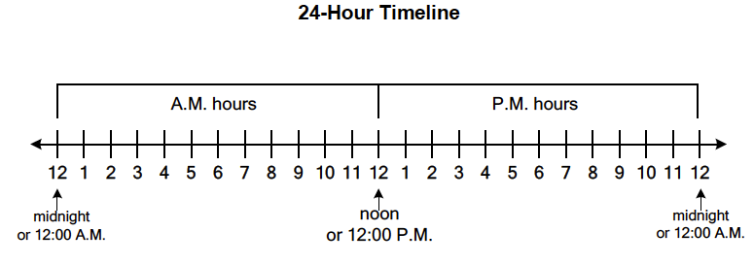

**Chapter 6: Operations with time**

|  |  |
| --- | --- |
|  | **Converts hours to minutes** |
| 1. | 5 Hours |
| 2. | 3 Hours 50 minutes |
| 3. | 2 Hours 45 minutes |

|  |  |
| --- | --- |
|  | **Converts minutes to hours** |
| 1. | 420 minutes |
| 2. | 430 minutes |
| 3. | 136 minutes |

|  |  |
| --- | --- |
|  | **Solve** |
| 1. | 3 Hours 15 minutes + 2 hours 10 minutes |
| 2. | 5 hours 23 minutes + 7 hours 17 minutes |
| 3. | 8 hours 23 minutes - 1 hour 19 minutes |
| 4. | 5 hours 55 minutes-5 hours 39 minutes |

|  |  |
| --- | --- |
| 1. | Gyan's mother goes to the market at 4:15 PM and comes back home at 6:30PM. How much time did she take? |
| Ans: |  |
| 2. | Kavya goes out to play in the park at 5:15PM and comes back home after 1 hour 25 minutes. At what time does she come home? |
| Ans: |  |

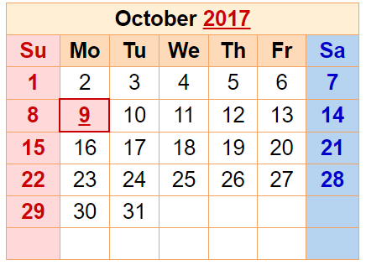

**Read the calendar and fill in the blanks**

|  |  |
| --- | --- |
| 1. | 8 October falls on a _______________ |
| 2. | There are ------------ Mondays in October 2017 |
| 3. | If Diwali is on 19th October 2017, what day will it be? ----------- |

|  |  |
| --- | --- |
|  | Draw clocks to show the given time |
| 1. | 08:05:15 |
| 2. | 04:50:41 |
| 3. | 02:36:58 |

Draw the hands of clock to show the time as 10:10:10

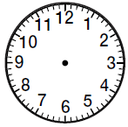

|  |  |
| --- | --- |
| 1. | There are ---------------- weeks in 35 days |
| 2. | There are ___________ months in 2 years. |
| 3. | Convert 3 hours 15 minutes into minutes |
| Ans |  |
| 4. | 4 Hours 45 minutes into minute |
| Ans: |  |
| 5. | Ramya takes 12 minutes to take one round of the park and Kiya takes 600 seconds. Who takes more time and how much more time? |
| Ans: |  |
| 7. | Solve |
| A | 4 hours+ 6 hours |
| B | 45 minutes + 7 minutes |
| C | 6 hours + 1 hour 45 minutes |
| D | 2 hours 15 minutes + 8 hours 17 minutes |
| 8. | Hari takes 1 hour 15 minutes to reach the office and 2 hours 10 minutes to reach home from the office,. How much time does Hari spend travelling. |
| Ans |  |
| 9 |  |

**Perimeter**

**Find the perimeter of rectangle**

|  |  |
| --- | --- |
| 1. | Length=13cm, Breadth=6cm |
| 2. | Length=10cm, Breadth=5cm |
| 3. | Length=17cm, Breadth=11cm |
| 4. | Length=30cm, Breadth=24cm |
| 5. | Length=22cm, Breadth=16cm |
| 6. | Length=12cm, Breadth=10cm |
| 7. | Length=15cm, Breadth=8cm |
| 8. | Length=15m, Breadth=3m |
| 9. | Length=10m, Breadth=7m |
| 10. | Length=1m, Breadth=10cm |
| 11. | Length=1m, Breadth=60cm |
| 12. | Length=4cm, Breadth=3cm |

**Find the perimeter of square**

|  |  |
| --- | --- |
| 1. | Side=6cm |
| 2. | Side=4cm |
| 3. | Side=10m |
| 4. | Side=10cm |
| 5. | Side=20cm |
| 6. | Side=2cm |
| 7. | Side=6cm |
| 8. | Side=10cm |

|  |  |  |  |  |  |  |  |  |  |  |  |  |  |
| --- | --- | --- | --- | --- | --- | --- | --- | --- | --- | --- | --- | --- | --- |
| A |  |  |  | B |  |  |  |  | C |  |  |  |  |
|  |  |  |  |  |  |  |  |  |  |  |  |  |  |
|  |  |  |  |  |  |  |  |  |  |  |  |  |  |
|  |  |  |  |  |  |  |  |  |  |  |  |  |  |
|  |  |  |  |  |  |  |  |  |  |  |  |  |  |
|  |  |  |  |  |  |  |  |  |  |  |  |  |  |
| D |  |  |  |  |  |  | E |  |  |  |  |  |  |
|  |  |  |  |  |  |  |  |  |  |  |  |  |  |
|  |  |  |  |  |  |  |  |  |  |  |  |  |  |
|  |  |  |  |  |  |  |  |  |  |  |  |  |  |
|  |  |  |  |  |  |  |  |  |  |  |  |  |  |
|  |  |  |  |  |  |  | F |  |  |  |  |  |  |
|  |  |  |  |  |  |  |  |  |  |  |  |  |  |

|  |  |  |  |  |  |  |  |  |  |  |  |  |  |  |  |  |
| --- | --- | --- | --- | --- | --- | --- | --- | --- | --- | --- | --- | --- | --- | --- | --- | --- |
| 1. | | The perimeter of a rectangular playground is 00m. If the length of the playground is 30m, what is its breadth? | | | | | | | | | | | | | | |
| Ans: | |  | | | | | | | | | | | | | | |
| 2 | | Find the perimeter of a rectangle with length 8 cm and breadth 5cm | | | | | | | | | | | | | | |
| Ans: | |  | | | | | | | | | | | | | | |
| 3. | | The perimeter of a square is 32cm. Find the length of its side. | | | | | | | | | | | | | | |
| Ans: | |  | | | | | | | | | | | | | | |
| 4. | | A boy runs around a rectangular ground. Its length is thrice its breadth. If the boy covers 2km in 5 rounds, find the length of the ground. | | | | | | | | | | | | | | |
| Ans: | |  | | | | | | | | | | | | | | |
| 5. | | A man runs around a square park and covers 1 km in five rounds. What is the length of each side of the park? | | | | | | | | | | | | | | |
| Ans: | |  | | | | | | | | | | | | | | |
| 6. | | The sum of the perimeter of two identical squares is 80cm. What is the length of the side of each square? | | | | | | | | | | | | | | |
| Ans: | |  | | | | | | | | | | | | | | |
| 7. | | If the perimeter of a square is 16cm, what is the length of the sides of the square? | | | | | | | | | | | | | | |
| Ans: | |  | | | | | | | | | | | | | | |
| 8. | | A fence has to be constructed around a rectangle zoo. If the zoo is 3km long and 1 km wide, what will be the length of the fence to be constructed? | | | | | | | | | | | | | | |
| Ans: | |  | | | | | | | | | | | | | | |
| 9. | | Find the perimeter of a rectangle with length=35cm and breadth=3cm | | | | | | | | | | | | | | |
|  |  | |  |  |  |  |  |  |  |  |  |  |  |  |  |
|  |  | |  |  |  |  |  |  |  |  |  |  |  |  |  |
|  |  | |  |  |  |  |  |  |  |  |  |  |  |  |  |
|  |  | |  |  |  |  |  |  |  |  |  |  |  |  |  |
|  |  | |  |  |  |  |  |  |  |  |  |  |  |  |  |
|  |  | |  |  |  |  |  |  |  |  |  |  |  |  |  |
|  |  | |  |  |  |  |  |  |  |  |  |  |  |  |  |
|  |  | |  |  |  |  |  |  |  |  |  |  |  |  |  |
|  |  | |  |  |  |  |  |  |  |  |  |  |  |  |  |
|  |  | |  |  |  |  |  |  |  |  |  |  |  |  |  |

**Area**

Draw a shape having 12 square units area on a square paper.

|  |  |  |  |  |  |  |  |  |  |  |  |  |  |  |
| --- | --- | --- | --- | --- | --- | --- | --- | --- | --- | --- | --- | --- | --- | --- |
|  |  |  |  |  |  |  |  |  |  |  |  |  |  |  |
|  |  |  |  |  |  |  |  |  |  |  |  |  |  |  |
|  |  |  |  |  |  |  |  |  |  |  |  |  |  |  |
|  |  |  |  |  |  |  |  |  |  |  |  |  |  |  |
|  |  |  |  |  |  |  |  |  |  |  |  |  |  |  |
|  |  |  |  |  |  |  |  |  |  |  |  |  |  |  |
|  |  |  |  |  |  |  |  |  |  |  |  |  |  |  |
|  |  |  |  |  |  |  |  |  |  |  |  |  |  |  |
|  |  |  |  |  |  |  |  |  |  |  |  |  |  |  |
|  |  |  |  |  |  |  |  |  |  |  |  |  |  |  |
|  |  |  |  |  |  |  |  |  |  |  |  |  |  |  |
|  |  |  |  |  |  |  |  |  |  |  |  |  |  |  |
|  |  |  |  |  |  |  |  |  |  |  |  |  |  |  |
|  |  |  |  |  |  |  |  |  |  |  |  |  |  |  |
|  |  |  |  |  |  |  |  |  |  |  |  |  |  |  |

2) Find the area 0f the coloured shapes

|  |  |  |  |  |  |  |  |  |  |  |  |  |  |
| --- | --- | --- | --- | --- | --- | --- | --- | --- | --- | --- | --- | --- | --- |
| A |  |  |  | B |  |  |  |  | C |  |  |  |  |
|  |  |  |  |  |  |  |  |  |  |  |  |  |  |
|  |  |  |  |  |  |  |  |  |  |  |  |  |  |
|  |  |  |  |  |  |  |  |  |  |  |  |  |  |
|  |  |  |  |  |  |  |  |  |  |  |  |  |  |
|  |  |  |  |  |  |  |  |  |  |  |  |  |  |
| D |  |  |  |  |  |  | E |  |  |  |  |  |  |
|  |  |  |  |  |  |  |  |  |  |  |  |  |  |
|  |  |  |  |  |  |  |  |  |  |  |  |  |  |
|  |  |  |  |  |  |  |  |  |  |  |  |  |  |
|  |  |  |  |  |  |  |  |  |  |  |  |  |  |
|  |  |  |  |  |  |  | F |  |  |  |  |  |  |
|  |  |  |  |  |  |  |  |  |  |  |  |  |  |

|  |  |
| --- | --- |
| 3 | Find the area of the following using rajma beans  a. Ruler b. Ice cream stick c. cover of your notebook d. top of your lunch box  e. top of your table f. one half of handkerchief g. top of any empty box |
| 4. | Draw 2 shapes on a square paper having the perimeter as given below and compare the areas.  a. 6 b. 10 c. 15 d. 20  e. 8 f. 14 g. 16 h=22 |
| 5. | The area of a shape is 18 square units. Find 3 possible perimeters and draw shapes. |

**6. Find area of irregular shapes**

|  |  |  |  |  |  |  |  |  |  |  |  |  |  |  |
| --- | --- | --- | --- | --- | --- | --- | --- | --- | --- | --- | --- | --- | --- | --- |
|  |  |  |  |  |  |  |  |  |  |  |  |  |  |  |
|  |  |  |  |  |  |  |  |  |  |  |  |  |  |  |
|  |  |  |  |  |  |  |  |  |  |  |  |  |  |  |
|  |  |  |  |  |  |  |  |  |  |  |  |  |  |  |
|  |  |  |  |  |  |  |  |  |  |  |  |  |  |  |
|  |  |  |  |  |  |  |  |  |  |  |  |  |  |  |
|  |  |  |  |  |  |  |  |  |  |  |  |  |  |  |
|  |  |  |  |  |  |  |  |  |  |  |  |  |  |  |
|  |  |  |  |  |  |  |  |  |  |  |  |  |  |  |
|  |  |  |  |  |  |  |  |  |  |  |  |  |  |  |

|  |  |
| --- | --- |
| 7 | Find the area if perimeter of square is  a. 8 b. 16 c. 24 d. 48 e.40 |
| 8 | There are 24 matchsticks to make a boundary of a park. What will be the largest and shortest area of the park? |
| 9 | There are 16 toothpicks to make a fence around a basket ball court. If the required area of the court is 15 square units, then draw the shape. |
| 10 | There are 30 matchsticks to make the boundary of a garden. What will be the largest and the shortest area of the garden. |

**Money**

|  |  |
| --- | --- |
| 1. | Convert Rs. 3 to paise |
| 2. | Convert 500p to rupees |
| 3. | Convert into paise  a. **4 rupees 65 paise** b. **13 rupees 23 paise** |
| 4. | Convert into rupees  a**. 4600 paise** b.**910 paise** |
| 5. | Make the given amount in 3 different ways  a. **Rs. 512**  b. **Rs 274** |
| 6. | Write the total amount  Five **Rs. 50 notes** + One **Rs 10 notes** +six **Rs. 20 notes**  Three **Rs. 50 notes** + Two **Rs 100 notes** +one **Rs 10 notes** + one **50 coin.** |
| 7. | Read the given price list   |  |  | | --- | --- | | **Item** | **Cost** | | Pencil Box | Rs.55 | | Erasers (set of 12) | Rs.48 | | Pen(set of six) | Rs. 90 | | Water bottle | Rs.115 |   **a. What is the total cost of 5 water bottles?**  **b. If you bought one dozen erasers and you are left with Rs. 95, how much money**  **did you have?**  **c. What will be the cost of 3 pens and 6 eraser** |
| 8. | Prepare a bill for 2 pens, 3 pencil boxes and 4 erasers. |
| 9. | If the cost of 2 dozen bananas is Rs120, what is the cost of 6 bananas? |
| 10. | Convert into paise  **a. Rs.12 and 15 paise**  **b. Rs. 8 and 19 paise**  **c. Rs.25 and 45 paise**  **d. Rs. 6 and 31 paise** |
| 11. | Convert into rupees  **a. 5795 paise b. 821 paise c. 7194 paise d. 618 paise** |
| 12. | Write the different notes and coins used to make the given amount.  **a. Rs. 312 b. Rs 191 Rs. 425 Rs. 83** |
| 13 | Write the total amount  a. One **Rs. 100 note** + Six **Rs 10 notes** +six Five Rs. 5 coins  b. Six **Rs. 50 notes** + Three **Rs. 10 notes** +Five 5o paise coins + Two Rs.20 notes  **c.** Two **Rs. 10 notes +** Three **Rs. 50 motes +** Six **Rs. 100 notes**  d. Three **Rs. 50 notes** + Four **Rs. 100 notes** + Six **50 paise coins** + Two **Rs. 10 notes** |
| 14 | Give below is the price of some fruits   |  |  |  |  |  | | --- | --- | --- | --- | --- | | Item | Pineapple | Bananas(1 dozen) | Oranges (6) | Watermelon | | Cost | Rs.55 | Rs.48 | Rs.90 | Rs.115 |   a. The cost of 2 oranges is Rs.  b. The cost of 4 pineapples is Rs.  c. the cost of 6 bananas and 1 watermelon is Rs.  d. I need Rs. more if I have Rs. 500 and I buy 5 watermelons. |
| 15 | What is the total cost of 5 watermelons? |
| 16 | If you buy one dozen oranges and you are left with Rs. 95, how much money did you have? |
| 17. | What will be the cost of 3 oranges and 6 bananas? |
| 18. | If have one Rs. 500 note and I buy a pineapple and watermelon, how much money is left with me? |
| 19. | Complete the given bill.   |  |  |  |  | | --- | --- | --- | --- | | Item | Cost per unit | No. of Items | Total cost | | Pineapple |  | 2 | Rs.110 | | Bananas | Rs.4 | 12 |  | | Oranges |  |  | Rs.60 | | Watermelon | Rs.115 |  | Rs.230 | |  |  | Total amount |  | | Change amount on using a Rs. 500 note | | |  | |
| 20 | Read the given price list.  a. Prepare a bill for 6 bananas, 2 pineapples and 1 watermelon  b. Prepare a bill for 2 dozen bananas and 12 oranges.   |  |  |  |  |  | | --- | --- | --- | --- | --- | | Item | Pineapple | Bananas (1 dozen) | Oranges(6) | Watermelon | | Cost | Rs.55 | Rs.48 | Rs.90 | Rs.115 | |

http://www.math-salamanders.com/telling-time-worksheets.html

http://www.math-salamanders.com/math-salamanders-search-results.html?cx=partner-pub-4030090884118338%3A6475248065&cof=FORID%3A10&ie=UTF-8&q=reading+clock&sa=Search&siteurl=www.math-salamanders.com%2Fclock-worksheet.html&ref=www.google.co.in%2F&ss=1885j381359j13

